Beginner’s Guide to Simple API - 1

In part one we will deal with setting up VB to use API and we will look at a popular API call. The simple application created in this tutorial is supplied in example.zip

What is Win32 API?

Windows 32-Bit Application Programming Interface. It may sound complicated but you will soon see how simple it can be. API opens up the use of features used in writing many commercial applications.

Getting Started - Declarations

Before using API calls, as they are called, you need to declare the functions you will use. The easiest way to insert the right declarations is to use the API Viewer.

- Open VB and select “Standard EXE”
- Click the Add-Ins menu
- If “API Viewer” is on the menu, click on it and skip Step 4
- If you cannot see the menu item, click “Add-In Manager”. The following screen will appear.
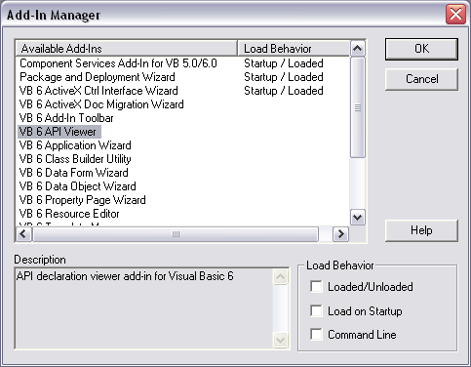

Select the “VB 6 API Viewer” item under Available Add-Ins. Check the two boxes highlighted. (Loaded/Unloaded and Load on Startup) Click OK. Now select the Add-Ins menu again. The API Viewer should appear. Click on it.

- The following window will appear.

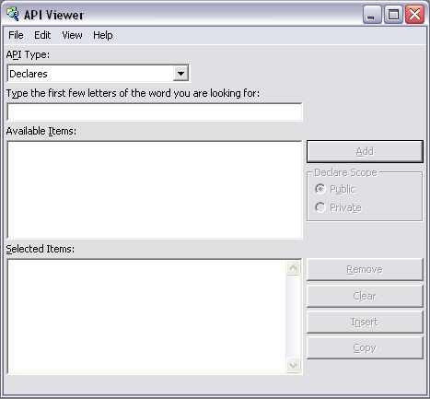

Click File > Load Text File. Three text files should appear in the Open dialog. Open WIN32API.txt
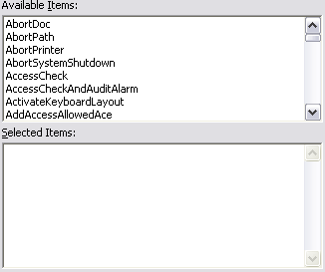
The list of API calls will be populated.

In the box above “Available Items”, type ShellE.

In the Declare Scope area, select Private.

Double-click ShellExecute in the API list, then click the Insert button.

- The API declaration has appeared in Form1’s code.
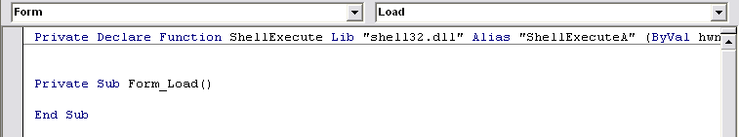

Using the Declaration

You have just inserted the ShellExecute API declaration. This is used for opening files, folders and websites.

Put a button on Form1 and call it cmdShell. Make its caption ShellExecute. Double-click it to open its code.

Add this code:

Private Sub cmdShell_Click()

Dim shellsuccess As Long

shellsuccess = ShellExecute (fH,”Open”,”http://www.google.com”, 0&, 0&, 10)

End Sub

You can alter the “http://www.google.com” to whatever site you like, or to a path on your computer. You can open any file, folder or website in this way.

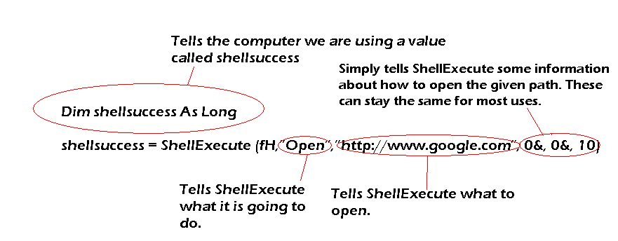
Here’s the explanation:

Run the application and click the button. Google should open in your default web browser.

Coming Soon..!

Look out for part two of this API tutorial on Planet Source Code. It will contain information on more API calls and how to use them.

Thanks for using my tutorial. Please vote for me.

Regards,

Tom Hendriks

